Half Term Work

Aim: One of the problems that many people face is keeping track of events and what they have on the calendar, for example booking two matches on the same day with different people. Therefore, it would be helpful to have a defense system in place that warns you that you have double booked yourself and prevent you from making this mistake.

Method:

I started off with adding a new public virtual Boolean to golfer called within match. Whenever a golfer is in a match this Boolean will be true and if not will be set to false.

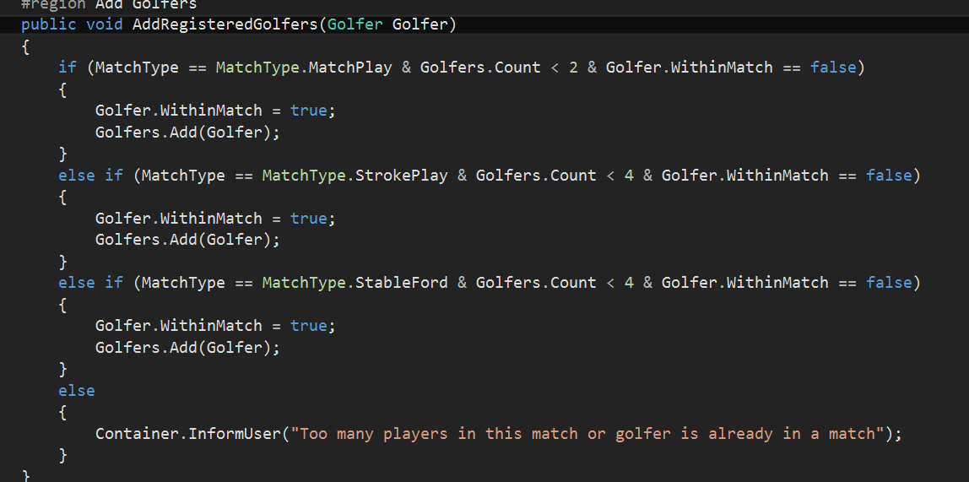

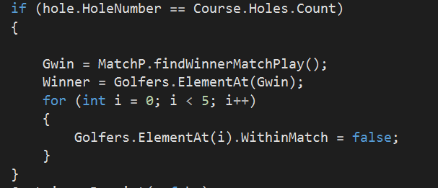

I’ve added this “for” iteration to all of the match types.

To show how this works ive created a test Golfer and two test matches added the test person to the first test match and then attempted to add him to the second but failed due to the new code prevent me from adding him. This is shown in the screenshots below.

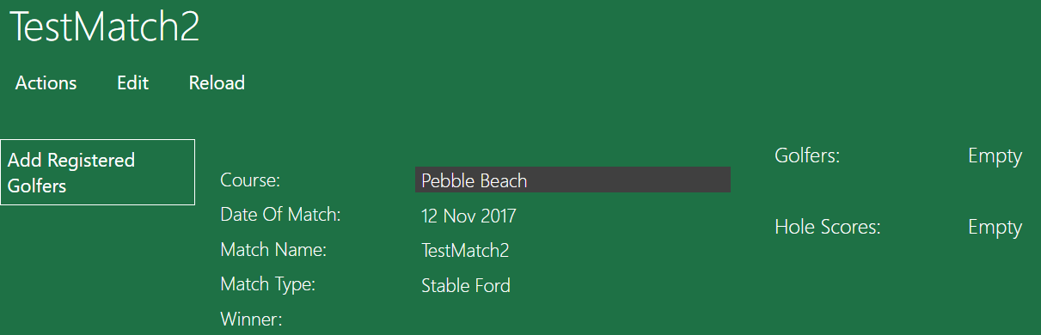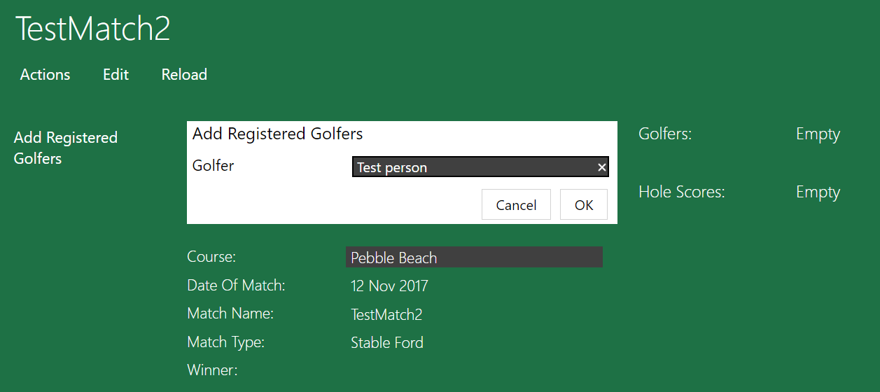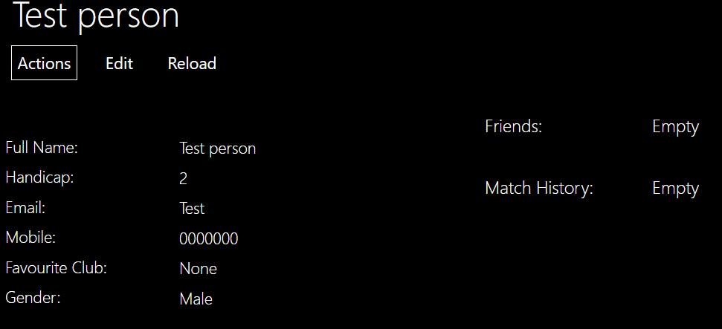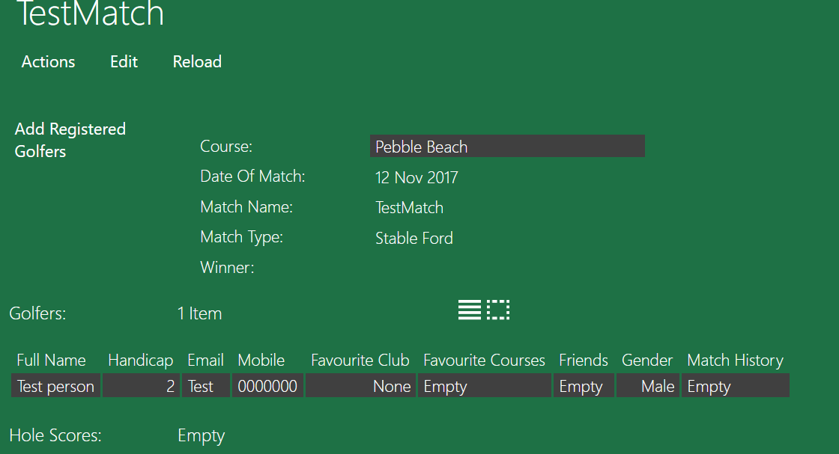

Straight away you can notice that this means that they can’t join a match on any other date until that match has been finished which could be a problem for the busier golfers and is an area to improve on in a later date.